**E-Banking system software**

**Group 2**

**Roll No. and Name** :- 1714086 Hritik Jaiswal

1714096 Niket Mehta

1714097 Riddhisha Nirmal

1714100 Vedang parasnis

**Server**: Authentication, user Data, file uploads, Payment options, Delete Account

**Client**: Login, Logout, Forgot Password, Dashboard , ChatBot ,RazorPay

**Database**: user Info, transactions

**Devops :** Docker

**Project scope:**

* From an end user perspective, the E Banking system project consists of the functional element which is Customer transaction module
* Provide all bank detail and payment gateway, make responsive UI for client and provide facilities to them.

**Choice of process model** :

* **backend –** Mongodb , firebase ,node.js , express , route handler , firebase cloud function
* **Front-end** : angular-js ,react , JavaScript

**Role and Responsibilities**:

* Team leader : Riddhisha Nirmal
* Developer : Vedang Paransis
* Designer : Hritik Jaiswal
* Tester : Niket Mehta

**GUI Based Implementation of one module :**

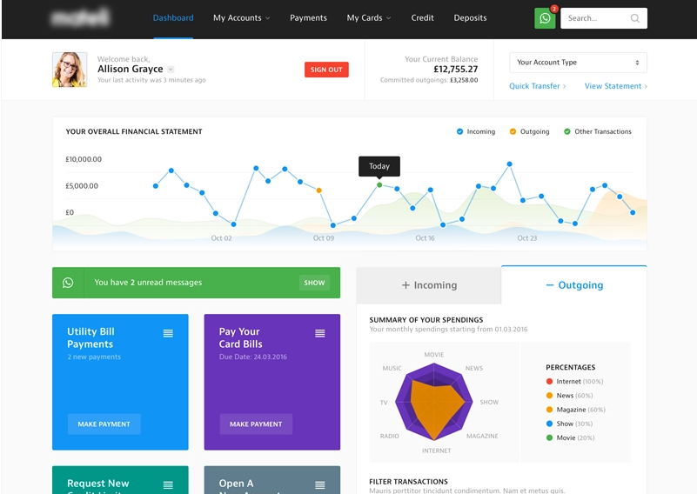

**Peer Discussion**:

Add face recognition, finger print recognition to avoid false or duplicate creation of an account, if a user has all documents like aadhar card , PAN card , Photo Id proof that belongs to some other person and hence creating a fake account .

This could be solved to some extent by sending an OTP to the registered phone number or by using email verification.